Lab # 02



Fall 2024

**CSE-310L Control Systems Lab**

Submitted by: MUHAMMAD SADEEQ

Registration No.: 21PWCSE2028

Section: C

“On my honor, as a student of the University of Engineering and Technology, I have neither given nor received unauthorized assistance on this academic work”

Submitted to:

Dr. Muniba Ashfaq

(13 Oct 2024)

Department of Computer systems engineering

University of Engineering and Technology, Peshawar

**Find an impulse and step response of the following system by using Matlab. Use simulink to find both responses and compare them with Matlab results.**

**In Simulink**

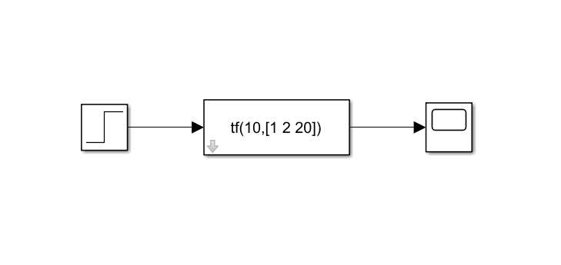

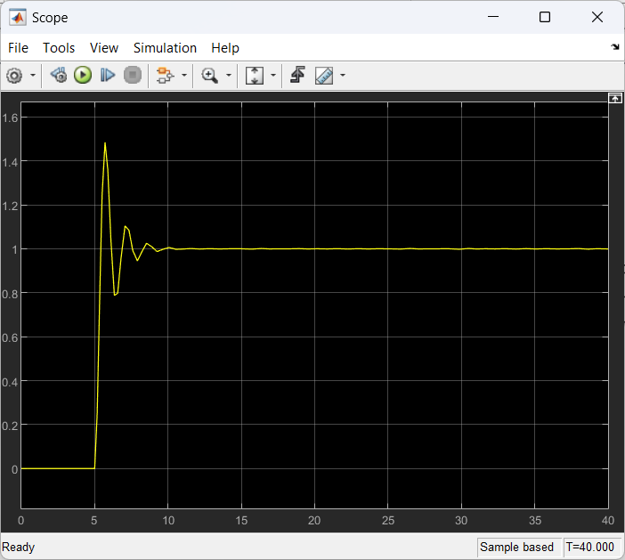

**In MATLAB**

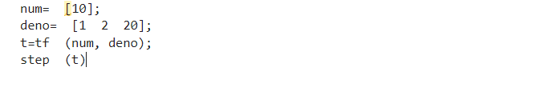

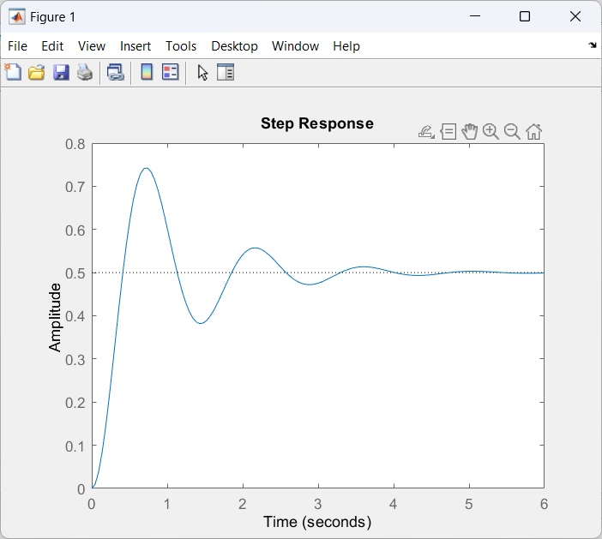

**In Simulink**

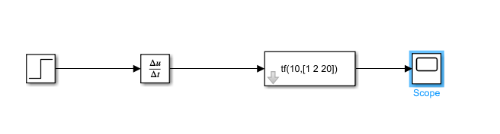

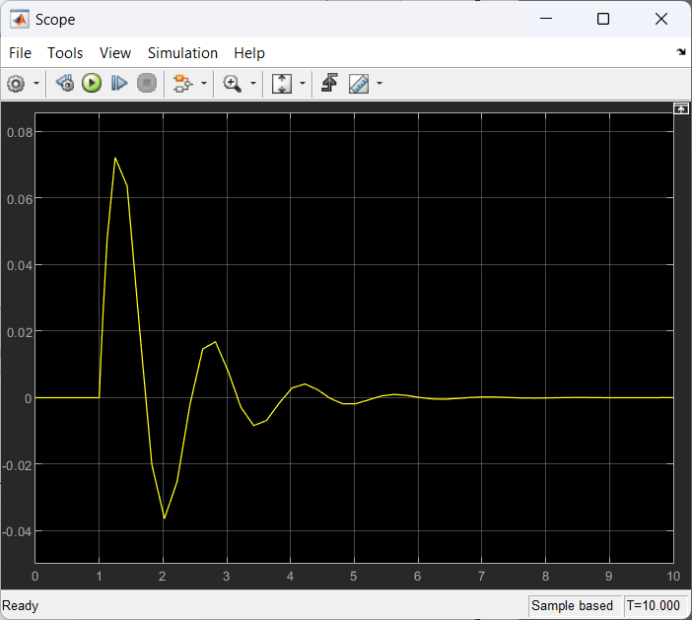

**In MATLAB**

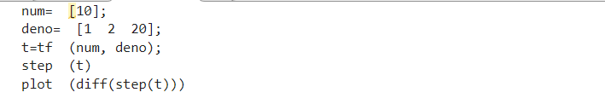

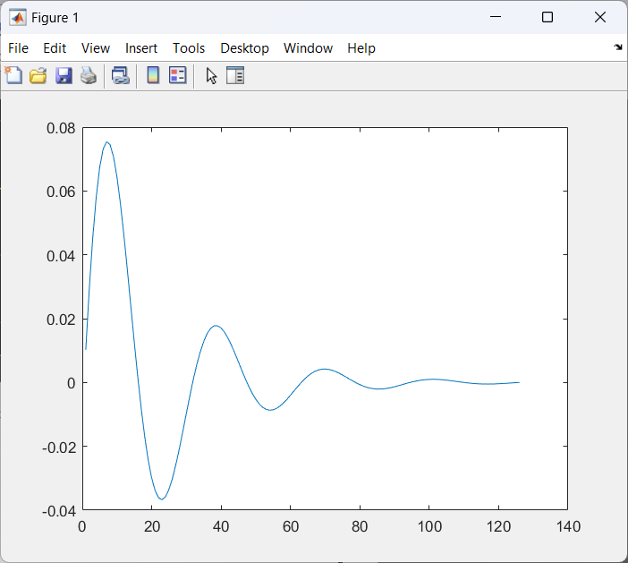

**Also apply the sinusoidal input to the above system in both Matlab and Simulink. Compare both the results too. Also plot output vs. input in both.**

**In Simulink**

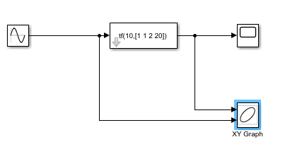

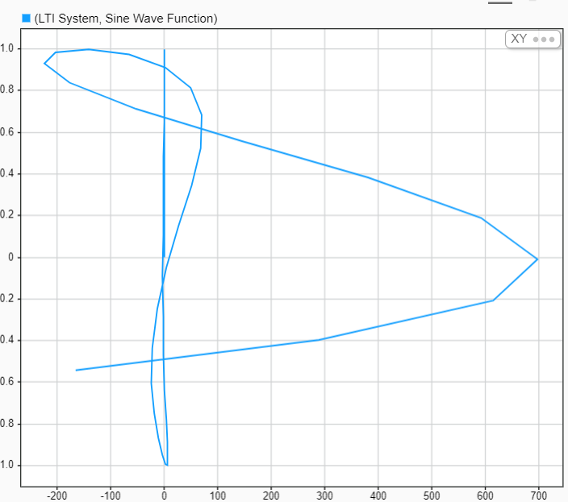

**In MATLAB**

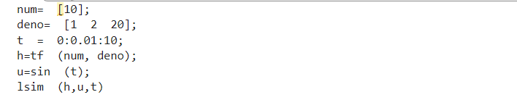

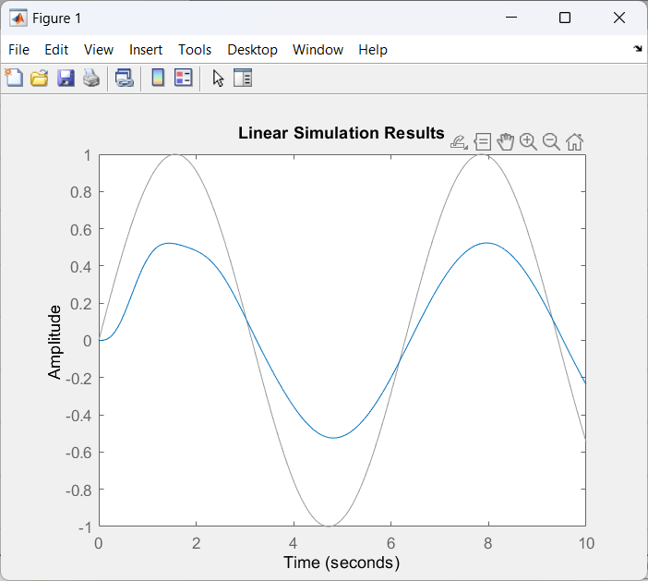

**3. Apply the following input to the system in both Simulink and Matlab. sin(2πt) + u(t) + 2u(t-5)**

**In Simulink**

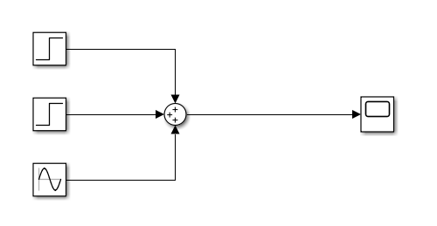

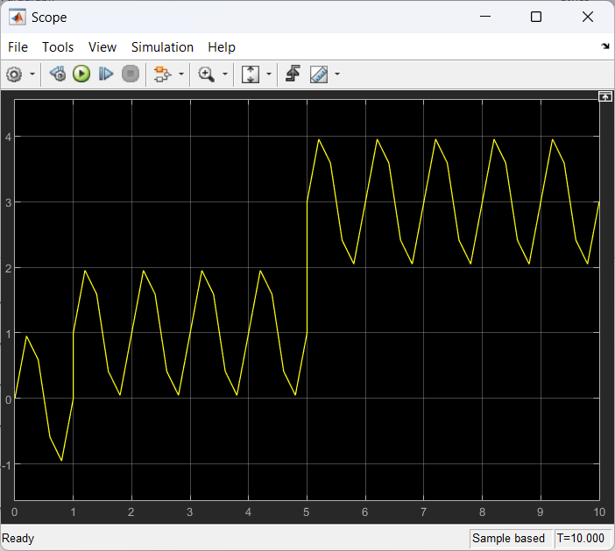

**In MATLAB**

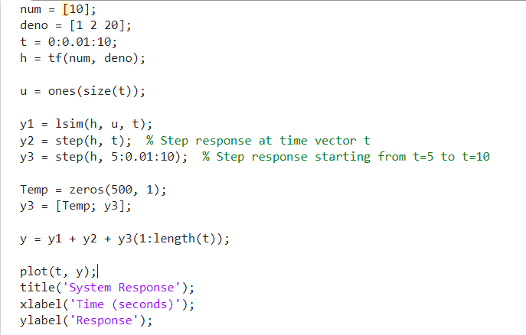

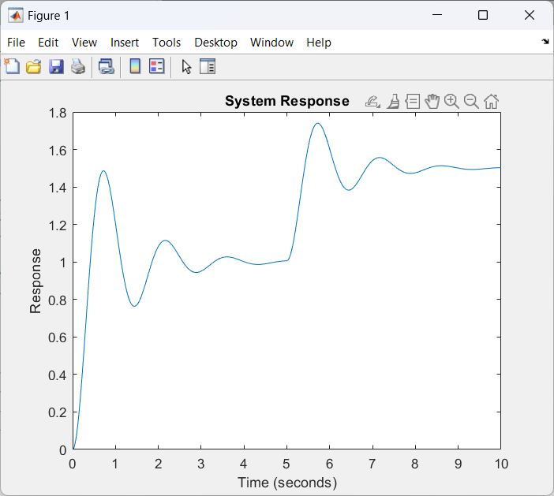

**4. Square input with amplitude equal to 1 and time period equal to 10 seconds. Simulate the system for at least 40 seconds.**

**In Simulink**

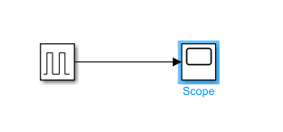

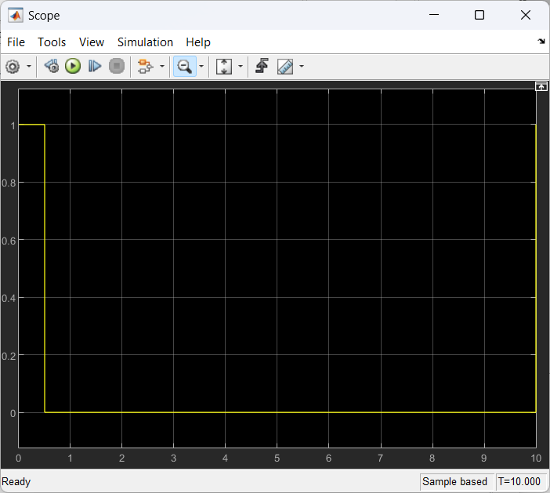

**In MATLAB**

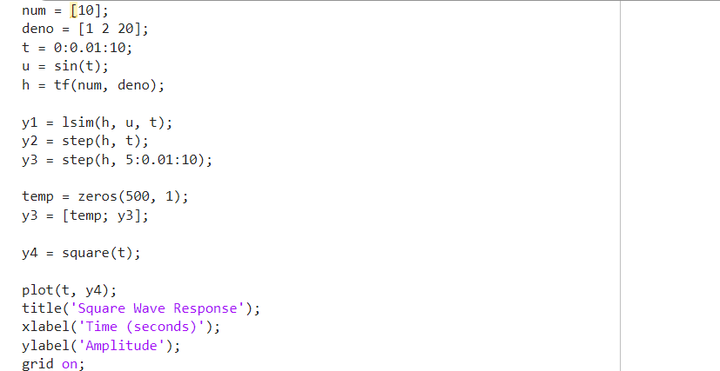

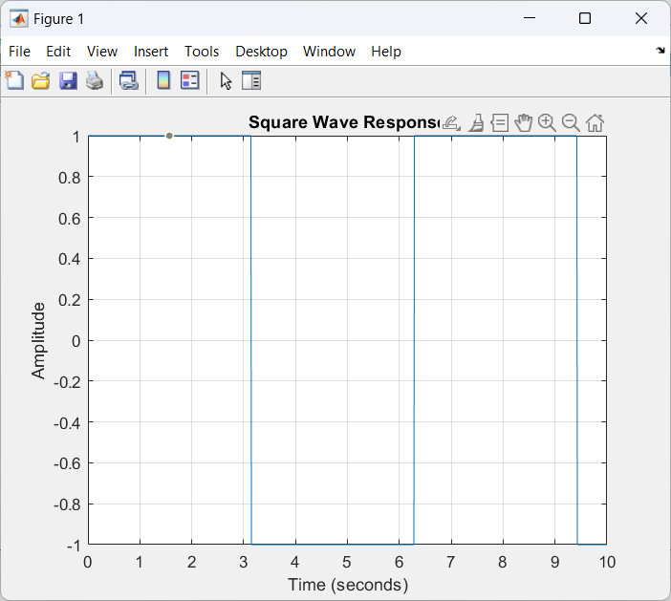

**Combine both of the inputs of Q#3 and Q#4.**

**In Simulink**

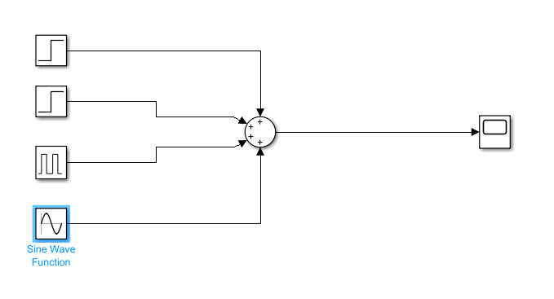

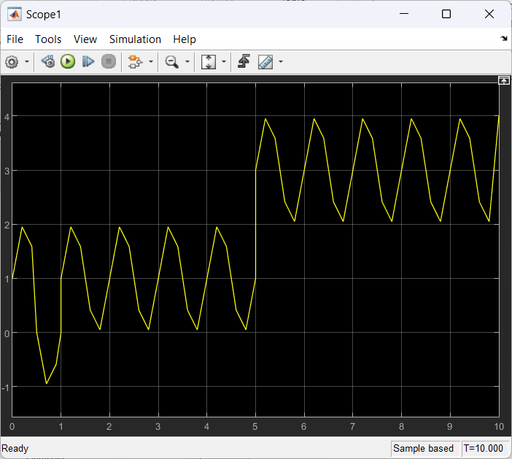

**In MATLAB**

